Home Automation

Requirements Document

Aaron Pettit

Signature Page

Reviewed by: __________________________________________ ____________

Name, Title, Email Date

Reviewed by: __________________________________________ ____________

Name, Title, Email Date

Reviewed by: __________________________________________ ____________

Name, Title, Email Date

Reviewed by: __________________________________________ ____________

Name, Title, Email Date

Reviewed by: __________________________________________ ____________

Name, Title, Email Date

|  |  |  |  |  |
| --- | --- | --- | --- | --- |
| Revision | Description | Author | Date | Approval |
| 1 | App update | Aaron Pettit | 12/7/18 | AP |
| 2 |  |  |  |  |
| 3 |  |  |  |  |
| 4 |  |  |  |  |
| 5 |  |  |  |  |
| 6 |  |  |  |  |
| 7 |  |  |  |  |
| 8 |  |  |  |  |
| 9 |  |  |  |  |
| 10 |  |  |  |  |

Revision History

Table of Contents

1. Scope 4

2. Applicable Documents 5

2.1. House electrical outlet and switch wiring: 5

2.2. IEEE safety standards 5

2.3. Android coding standards: 5

3. Requirements 6

3.1. Block Diagram 6

3.2. Phone App 6

3.2.1. Interface 6

3.2.2. Functional 8

3.3. Server 8

3.3.1. Functional 8

3.3.2. Non-Functional 9

3.4. Lighting Device 9

3.4.1. Functional 9

3.4.2. Non-Functional 9

3.5. Washer/Dryer Device 10

3.5.1. Functional 10

3.5.2. Non-Functional 10

4. Verification of Requirements 11

4.1. Phone App 11

4.1.1. Interface 11

4.2. Server 12

4.3. Lighting Device 12

4.4. Washer/Dryer Device 13

# Scope

This document establishes the requirements and testing for the Home Automation system. The Home Automation system allows a user to control the lighting in their home and to receive push notifications for their washing and drying machines. The user shall interface to this system through a mobile application. A server connected to the user’s home network shall connect to the mobile application, store data about the status of the system, and send commands to the various modules. The modules to be used are for a washing machine and light switches. The washing machine module shall detect if the washer/dryer is currently on. The light switch module shall turn on/off the light it is attached to.

# Applicable Documents

## House electrical outlet and switch wiring:

<https://up.codes/viewer/utah/irc-2015/chapter/40/devices-and-luminaires#40>

## IEEE safety standards

## Android coding standards:

<https://github.com/ribot/android-guidelines/blob/master/project_and_code_guidelines.md>

# Requirements

## Block Diagram

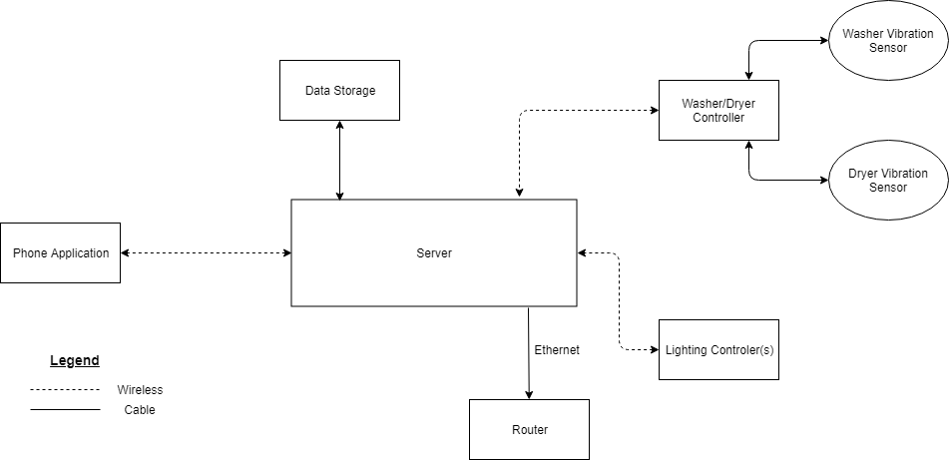

## Phone App

### Interface

#### General

There shall be a tab at the bottom of the screen for each of the modules.

When a tab is selected, the wording for the tab shall be underlined or highlighted to indicate it is active.

#### Lighting Control Screen

The word “Lighting” will be displayed on the tab.

A summary screen shall show all lights in a list with an on/off switch next to the name.

A button shall be present next to each list item to allow the user to modify that light.

The user shall be able to edit the name of the light fixture.

The light module shall operate in two modes: manual and timer.

The manual control shall behave like a light switch to turn the light on and off.

The manual control shall have a light-colored background for the on/off button when the light is on.

The manual control shall have a dark-colored background for the on/off button when the light is off.

There shall be a 1 ± 0.1 second delay between on/off presses before the button can be pressed again

The manual control shall always override the current mode. This override will end when the light is switched off using the app.

The timer control shall let the user to set a start and ending time for the light to turn on.

The timer shall have a default start time of sunset. This time will be obtained on the server.

The user shall be given the option to set the start/stop times to the default of sunset and sunrise.

The timer shall have a default end time of sunrise. This time will be obtained from the server.

The lighting summary page shall have a stopwatch icon next to the light if a timer is enabled.

#### Washer/Dryer Control Screen

If the app is open and the sensor detects that the washer is active, a popup will ask to set an alarm for the washer.

If the app is open and the sensor detects that the dryer is active, a popup will ask to set an alarm for the dryer.

The status of the washer and dryer shall be shown to the user. The status shown shall be “Active” if the machine is on, and “Idle” if the machine is off.

The app shall obtain data for the washer and dryer status from the server.

#### Settings Screen

A red “LOGOUT” button shall be displayed at the top of the screen.

A confirmation popup shall appear when the logout button has been pressed. Pressing OK will log out the user and bring them to the Logon Screen. Pressing cancel will close the popup.

An un-editable textbox shall display the ID of the user’s system.

#### Logon Screen

The logon screen shall contain two text fields for username and password.

The username text field shall contain the words “Server ID” when the text field is empty.

The password text field shall contain the word “Password” when the text field is empty.

The ID and password shall be found printed on the server box.

The password text field shall mask the input password as it is being typed.

A sign-in button shall be located below the username and password text fields.

Upon a failed login attempt, the username field will stay the same and the password field shall be cleared.

If the Server ID is not found, an error message shall display “Incorrect ID/password”.

If the password is incorrect, an error message shall display “Incorrect ID/password”.

The user shall stay logged in until they log themselves out.

A loading screen shall be displayed after the user presses the sign-in button. During this loading period, the app will ping the server for the lighting and washer/dryer information.

### Functional

#### Connection

The app must connect to the internet be able to communicate with the server.

If the app is unable to connect to the internet, an error message will pop up saying “Unable to connect to the server”.

A button labeled “retry” will be available on the error popup to try connecting to the server again.

The app shall send HTTP requests to obtain and send information to the server.

The app shall ping the server every 10 ± 0.1 seconds while the app is open for the status of all the devices.

If an alarm has been requested for the washer/dryer, the app will ping the server every 30 seconds while the app is closed.

## Server

### Functional

#### Software

There server shall accept HTTP requests from the app, process the request, and send the corresponding data to the app/device.

The server shall manage requests from the app and update the database.

When the database has been updated, the devices associated with the updated data shall be sent a command if required.

When a command is received to change the lights, the server will ping the lighting device for the status, update the database, then send the on/off command if required.

The server shall ping the washer device every 15 ± 0.1 seconds for the active status of the washer and update the database.

The server shall ping the dryer device every 15 ± 0.1 seconds for the active status of the dryer and update the database.

The server shall ping each lighting device every 15 ± 0.1 seconds for the on/off status of each light and update the database.

A web application API shall be used for the app to communicate with.

#### Hardware

A sticker with the Home Automation ID and password shall be place server case visible to the user.

### Non-Functional

#### Hardware

The server shall be hosted on a Raspberry Pi 3.

The Raspberry Pi shall be connected to a router via an ethernet cable.

The Raspberry Pi shall be plugged into a nearby 120V AC outlet using a micro USB cable and USB wall adapter.

A 32 GB SD card shall be used to storeall the data for the Raspberry Pi.

#### Software

The database shall be created by using SQL software to make handling data more standardized.

## Lighting Device

### Functional

#### Hardware

A software-controlled switch shall be used to turn the light on and off.

The switch shall be connected to the GPIO pins of the controller.

The controller shall have a Wi-Fi module to talk to the server.

#### Software

The device shall store the on/off status of the light in a variable.

The device shall receive a request from the server for the on/off status of the light. The device shall send a reply of 0 for off and 1 for on.

After sending the status reply to the server, the device shall receive Boolean value from the server to change the on/off variable.

When the on/off variable is set to 1, the relay shall close and turn on the light.

When the on/off variable is set to 0, the relay shall open and turn off the light.

### Non-Functional

#### Hardware

The device shall be mounted in the wall next to the light switch.

The controller shall be powered by connecting to the light switch wiring.

## Washer/Dryer Device

### Functional

#### Hardware

A vibration sensor shall detect the vibrations of the washing and drying machine.

The washer and dryer device must use two separate vibration sensors.

#### Software

The device shall read in data from the sensor every 0.5 seconds.

A variable shall contain the active status of the washer and dryer. The values shall be 1 for on, 0 for off.

Impulses of vibration shall not change the state of the variable.

To change the status of the washer and dryer to on, greater than 20% activity must be detected over 1 minute.

To change the status of the washer and dryer to off, less than 20% activity must be detected over 1 minute

The device shall receive requests from the server for the status of the washer and dryer.

When a request from the server has been received, the device will send two Boolean values. First shall be the washer status, second shall be the dryer status.

### Non-Functional

#### Hardware

The controller used shall be a Raspberry PI 3.

The controller shall be plugged into a nearby 120V AC outlet using a micro USB cable and USB wall adapter.

The vibration sensors shall be attached to the controller using 1 ft cables.

All components shall use magnets to attach to the back of the washer/dryer.

The magnets shall not impede the function of the sensor and the controller.

The device and sensors shall not slide down while the machine is vibrating.

# Verification of Requirements

## Phone App

### Interface

#### General

At the bottom of the screen, verify there is a tab for: Lighting, Washer/Dryer, and Settings. When the tab is selected, verify the wording is underlined

Change the status of a light in the database and verify the app reflects that change within 10 seconds.

#### Lighting Control Screen

Verify the number of lights displayed match the number of lighting modules in use.

Press the on/off switch for a light and visually verify the physical light turns on/off.

Verify when the on/off switch is pressed, there is a 1 second delay before it may be pressed again

Verify each light has a button to access more options for that specific light.

Verify the name of the light can be changed.

Verify a timer can be set with a start and end time.

Verify a timer icon appears on the main lighting page when a timer is enabled

#### Washer/Dryer Control Screen

While the app is open, verify a pop up appears to set an alarm when the washer/dryer is running.

Verify the washer and dryer status are correct with the physical status of the machines.

When an alarm is set, verify the alarm goes off within 1 minute and 20 seconds of the machine turning off. This time is the worst-case scenario.

#### Settings

Verify the system ID is displayed.

Verify when the logout button is pressed, a confirmation dialog appears.

Continue through the logout popup to verify the user is taken to the login screen.

#### Logon Screen

Verify the username textbox contains the text “Home Automation Server ID”.

Verify the password textbox contains the text “Password”.

Verify the password text field masks the input text.

Verify a sign-in button exists.

Enter an incorrect Server ID and a correct password, press sign-in. Verify the password field is erased and the error text displayed is “Incorrect ID/password”.

Enter a valid Server ID with an incorrect password and press sign-in. Verify the error text displayed is “Incorrect ID/password”.

Verify the user is taken to a home screen upon entering a correct username and password.

#### Connection

If the phone is not connected to the internet, verify an error popup displays saying, “Unable to connect to the server”.

Verify a retry button is available on the popup and the popup will go away once the phone is reconnected to the internet.

## Home Controller

#### Software

Verify the database entry for the washer and dryer updates every 15 ± 0.1 seconds.

Change a setting on the app and verify the server database changed to reflect that change.

Flip the physical switch for a light and verify the status is updated in the database.

Verify the database is updated within 15 seconds when the active status of the washer/dryer is changed on the washer/dryer controller

Verify the physical status of a light matches with the value in the database after the value gets changed in the database.

Verify the software used for the database is a type of SQL.

#### Hardware

Verify the controller used is a Raspberry PI.

Verify the controller is connected to a router through an ethernet cable.

Verify a 32 GB SD card is used for storage.

## Lighting Device

#### Software

Verify that when the status variable is changed to on, the light turns on.

Verify when the status variable is changed to off, the light turns off.

Verify the device can send and receive requests from the server.

#### Hardware

Verify the hardware can change turn on the light while it is currently off.

Verify the hardware can turn the light off while it is currently on.

Verify the module is hidden from the user in the wall.

## Washer/Dryer Device

#### Software

Verify the device obtains data from each sensor every 0.5 seconds or less.

Verify the device status doesn’t change when an impulse of vibration is detected such as foot stops.

Verify the device can send and receive requests from the server.

#### Hardware

Verify two separate vibration sensors are used.

Attach controller and sensors to a vibrating metal plate. Verify the devices do not slide down the surface.